- SUPPORTING INFORMATION
  - Airway Models
Figure S1 shows the airway with a deflated cuff tracheostomy tube inserted into the trachea (Model B.1), allowing air to flow around the cuff, and Figure S2 a cuffed tracheostomy tube inserted into the trachea (Model B.2), completely blocking airflow to the upper airway. Finally, Model C, shown in Figure S3, was modified by adding a subglottic tube to analyse vocalisation. The subglottic tube has specified inlet boundary conditions aimed at redirecting airflow through the upper airway and out the mouth.
Figure S1 (a) Model B.1, human airway model with an inserted cuff deflated tracheostomy tube to study airflow around the deflated cuff for inhalation and exhalation scenarios. (b) Dimensions of model additions to the healthy human airway model.
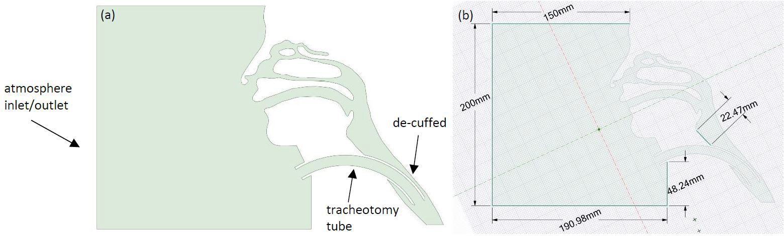

FIG. S2 (a) Model B.2, lower human airway model showing the inserted cuffed tracheostomy tube blocking the upper airway from any airflow. (b) Model dimensions regarding the atmosphere box as well as acquired tracheotomy tube dimensions.
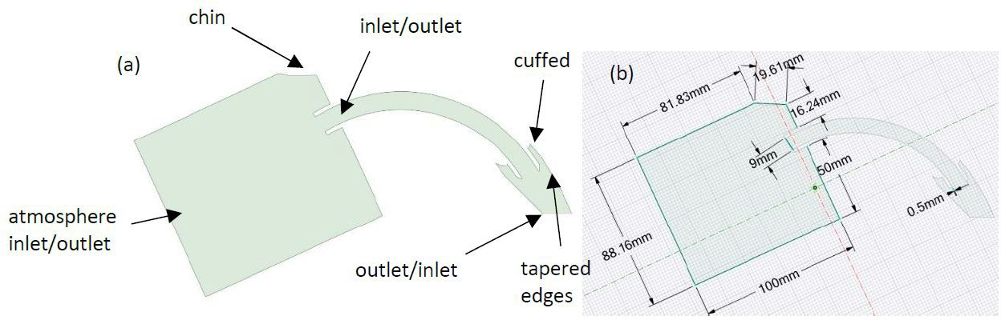
Figure S3 (a) Model C, upper airway model showing the subglottic tube outlet above the inflated cuff. (b) Subglottic tube dimensions measured using a physical model, focusing on the inlet and outlet diameters, as well as the distance from the cuff.
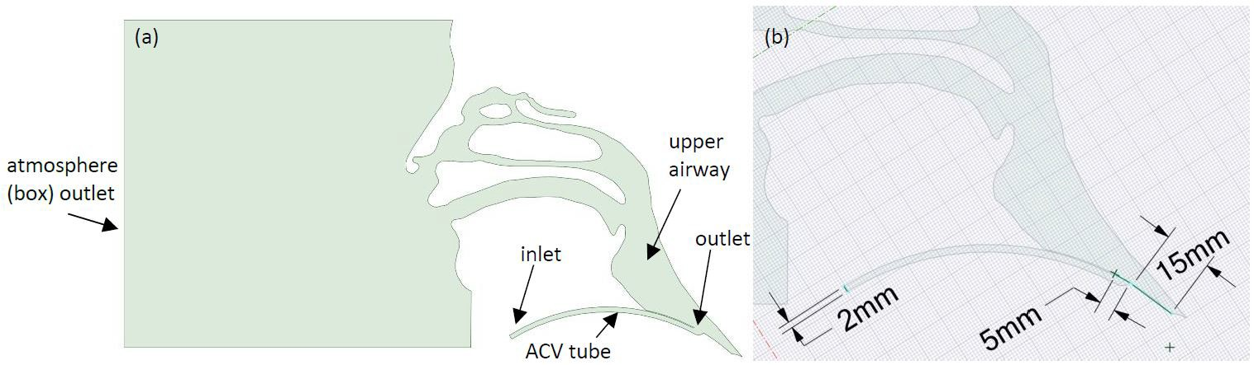
Figure S4 Representative mesh highlighting the unstructured mesh distribution at the boundary walls. Inset: magnified view of the computational domain near the larynx.
